OOP-LAB Task 6

Roll No: 24P-0706 | Dept: BS-CS
Name: Aazan Noor Khuwaja | Section : 2D

QNS-1:
#include<iostream>
#include<string>
using namespace std;

class university{
public:
string name_university;
university(string name):name_university(name){};
};
class department: public university{
public:
string dept_name;
department(string n,string d): dept_name(d),university(n){
};

};

class staff{
public:
int staff_id;
staff(int id):staff_id(id){}
};

class professor : public department , public staff{
public:
string subj_taught;
professor(string n_u , string d_u, int s_id, string s_t): department(n_u , d_u), staff(s_id) , subj_taught(s_t){};

void display_info()
{
cout <<"University : "<<name_university<<"\nDepartment : "<<dept_name<<"\nStaff ID : "<<staff_id<<"\nSubject Taught : "<<subj_taught<<endl;
}
};

int main()
{
professor p1("Fast University" , "Computer Science ",706, " Calculus and Linear Algebra ");
p1.display_info();

return 0;
}

Output: 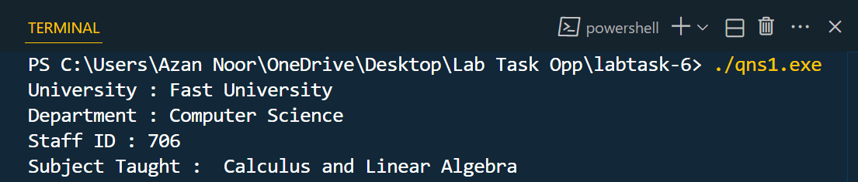

QNS-2:
Code:
#include<iostream>
using namespace std;
class person{
public:
string name;
int age;
person(string n , int a):name(n),age(a){};
};
class marks{
public:
float math_marks;
float science_marks;
marks(float a, float b):math_marks(a),science_marks(b){};
};

class student : public person,public marks{
public:
student (string n, int a, float math,float science ): person(n,a),marks(math,science){};

float calculate()
{
float sum=math_marks+science_marks;
float avg=sum/2;
return avg;
}

void display()
{
cout <<"Person Name : "<<name<<"\nPerson Age : "<<age<<"\nPerson Average Marks : "<< calculate()<<endl;
}
};

int main()
{
student s1("Aazan Noor Khuwaja",17,64,70);
s1.display();
return 0;
}

Output:
